Yulin Peng

User Manual for Aegisub

**Table of Contents**

Welcome Page 2

1. About Aegisub 3

Editing Subtitles 3

Typesetting 3

Timing 4

1. Main Screen 5

3. Editing Subtitles 7

4. Working With Styles 11

5. The Styles Manager 12

6. The Style Editor 14

7. Designing a Style 16

8. Timing Subtitles to Audio 21

# Welcome Page

Welcome to the online help for Aegisub. Aegisub is a software for adding subtitles to a video. You can learn how it works by reading the conceptual topics in other online help files. The step-by-step instructions included in this manual can help you start using Aegisub right away.

This manual currently includes the following topics:

1. About Aegisub
2. Main Screen
3. Editing Subtitles
4. Working With Styles
5. The Styles Manager
6. The Style Editor
7. Designing a Style
8. Timing Subtitles to Audio

Even though only a few topics are available for now, they include enough information for you to start adding subtitles to a video. More advanced topics are coming soon.

Let's get started!

# About Aegisub

Aegisub is a software for adding subtitles to a video. It supports subtitle formats such as:

1. Advanced Substation Alpha v4+ (.ass)
2. Substation Alpha v4 (.ssa)
3. SubRip Text (.srt)
4. MPEG4 Timed Text (.ttxt)
5. MicroDVD (.sub)
6. Plain "dialog script" formatted text (.txt)

The subtitles that are created in Aegisub can be saved in an .ass file. When you play the video, the media playing software combines the .ass file with the video file. Therefore, the subtitles can be displayed matching the corresponding audio.

The workflow of adding subtitles to a video can be divided into three phases:

1. Editing subtitles
2. Typesetting
3. Timing

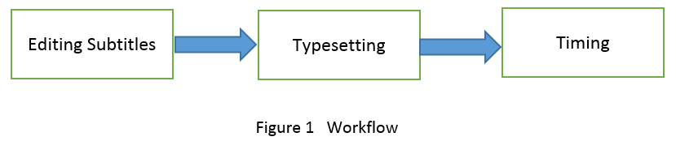

## [Editing Subtitles](mk:@MSITStore:C:\Users\Susan\Desktop\Aegisub%20Help.chm::/A_topitcs/EditingSubtitles.htm)

You can create subtitles by opening an empty subtitle file. Then you type scripts in separate lines in the subtitle file. You can also load your scripts into a subtitle file from other word-editing files. In the subtitle grid (multi-line subtitles display area), each line of subtitles is displayed with its line number, start time, end time, and CPS (characters per second). A red CPS in a line tells you that too many characters are displayed in a second. Red CPS means that the audience might not have enough time to read the subtitles while watching the video. When you see the red CPS in a subtitle line, you should consider making the line shorter.

## [Typesetting](mk:@MSITStore:C:\Users\Susan\Desktop\Aegisub%20Help.chm::/A_topitcs/WorkingWithStyles.htm)

Typesetting means to design the font size, font family, shadow, angle, and background of subtitles.

Typesetting is very important, because it affects the readability of subtitles. For example, if the color of subtitles is too close to the background color, the audience can’t see the subtitles clearly. Then subtitles lose their purpose. Therefore you need to design the typesetting to enhance the readability of subtitles.

Good typesetting not only helps the audience understand the scripts but also adds aesthetically pleasing visual effects to a video.

Aegisub has plenty of attributes for you to attain desired visual effects for subtitles.

## [Timing](mk:@MSITStore:C:\Users\Susan\Desktop\Aegisub%20Help.chm::/A_topitcs/Timing_subtitle_to_audio_file.htm)

Timing is important, because it lets the audience see the subtitles at the right time point. Subtitles need to be displayed in accordance with the actor's speech. Each line of subtitles should be displayed between the correct start and end time points.

To match the subtitles to the audio, you first play the audio in the audio area to locate the start and end points of a sentence. Then you associate the start and end points to corresponding subtitle line. After you have assigned the start and end time points to a subtitle line, you need to double-check the CPS to make sure that it is not red.

# Main Screen

Here is the main screen of Aegisub.

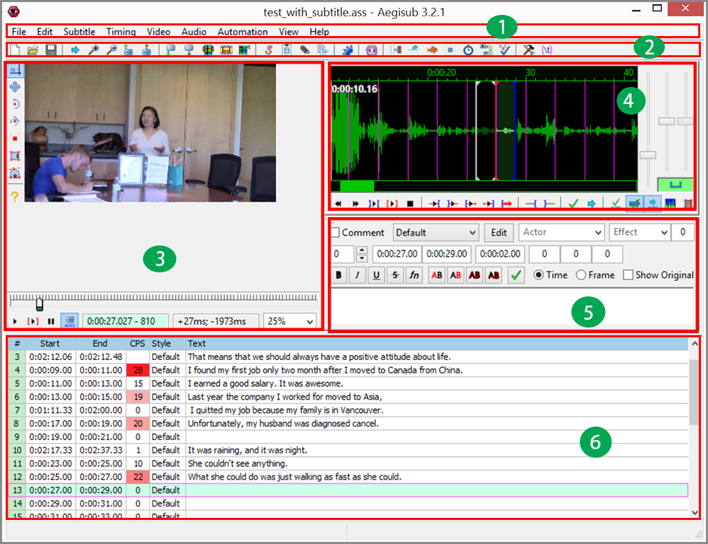

The descriptions for each area are in the following table.

|  |  |
| --- | --- |
| http://ylpeng.com/writings/aegisubHelp/images/1.png | **Menu Bar** contains all functions and divides functions into nine categories. Users click on a category menu to get the drop-down menu, and select the desired function from the drop-down menu. Here is how the functions are divided in each category:   * File menu includes functions such as opening, closing, saving, and exporting files. * Editing menu includes traditional editing functions such as copy and paste. * Subtitle menu includes functions to manipulate subtitles such as style design, language translation, spell check, and text editing. * Timing menu includes time shifting and post-processing. * Video menu includes functions such as opening video files and related files, as well as key frame operating. * Audio menu includes functions to open and close an audio file as well as other related operations. * Automation menu includes advanced batch process functions. * View menu lets users control the windows to be displayed or not displayed. * Help menu leads users to an online manual, user's forum, and other support resources. |
| http://ylpeng.com/writings/aegisubHelp/images/2.png | **Toolbar** contains icons for many frequently used functions. Users can fulfill a frequently conducted task by only one click on the corresponding icon. Using toolbar increases productivity by saving users' time spent on finding the sub-menu from the main menu. |
| http://ylpeng.com/writings/aegisubHelp/images/3.png | **Video Area** displays the video which you need to add subtitles to. Users can play and search on the video to check whether subtitles appear on the screen at the right time points. Users can also watch the video to see whether the typesetting of subtitles looks good or not. |
| http://ylpeng.com/writings/aegisubHelp/images/4.png | **Audio Area** displays an audio file in both waveform and spectrum. Users can locate the start and end time points for a selected subtitle sentence. Users can change the amplitude and time range displayed on the screen as well as play the video by clicking the buttons underneath the waveform. |
| http://ylpeng.com/writings/aegisubHelp/images/5.png | **Subtitles Editing Area** is where users edit subtitles. Main editing tasks that users can execute include changing time points, designing typesetting, and editing subtitle text. |
| http://ylpeng.com/writings/aegisubHelp/images/6.png | **Subtitles Grid** is a table for displaying subtitles. Each line of subtitles is displayed in one row with its line number, start time, end time, characters per second (CPS), typesetting style, and text in separate columns. Red color in CPS columns represents that too many characters are displayed in one second. |

# Editing Subtitles

Editing subtitles is the first task you have to do when you wish to add subtitles to a video. Having well-edited subtitles is essential to the process. Aegisub is a software originally designed for editing subtitles. The editing procedure is similar to that of a general text editing software, but Aegisub has some functions that are designed specifically for subtitle editing.

To edit subtitles:

1. From menu, Click **File | New Subtitles**. The subtitles editor and the subtitles grid will be displayed.

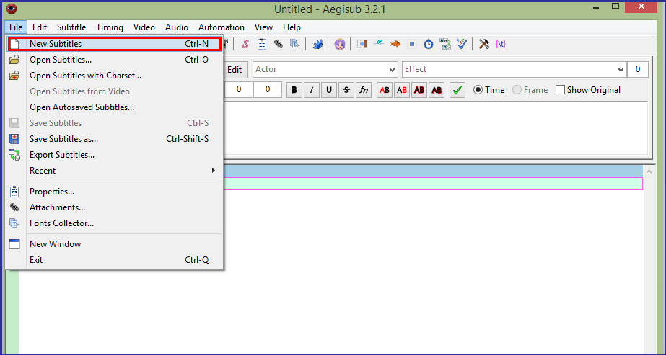

1. In subtitles editor, click the style drop-down (right of default) menu to select desired style from the list.

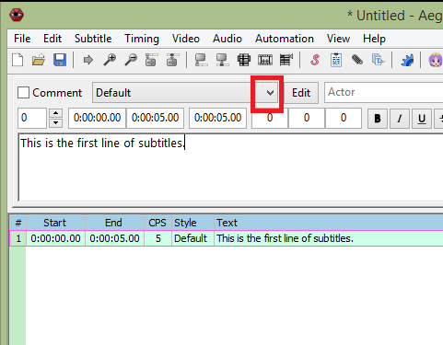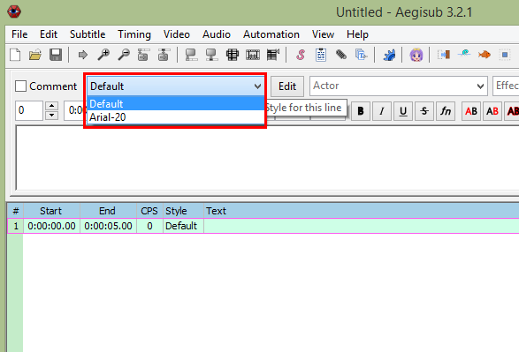

1. Type subtitles in the subtitles editor. The same subtitles will also be displayed in the subtitles grid.

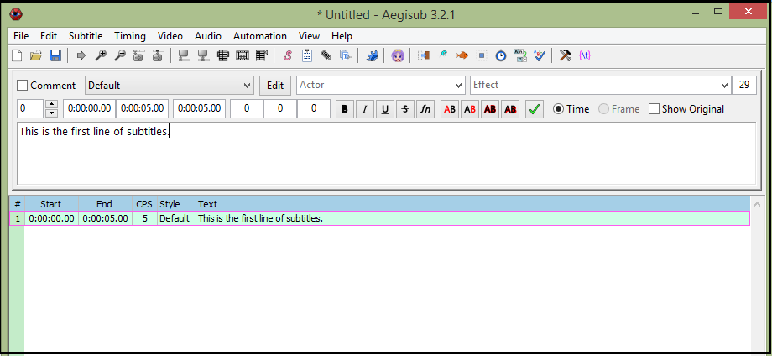

1. To finish the current subtitle line and start a new subtitle line, do one of the following:
   * Click **Commit** button.
   * Press Enter.

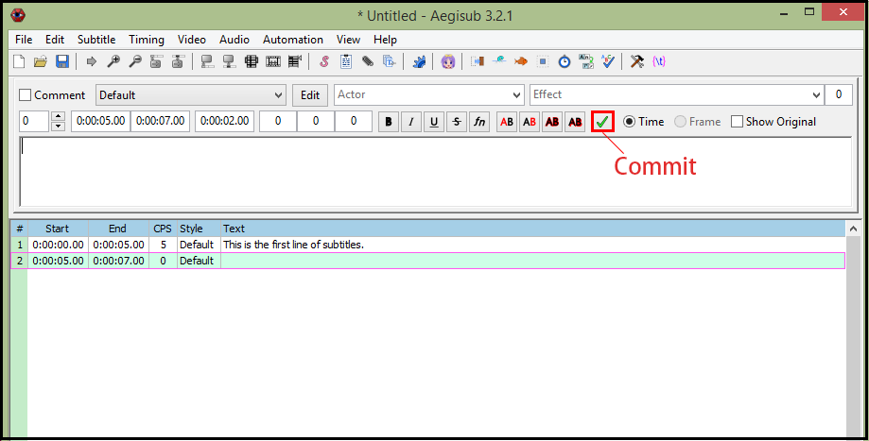

1. If you want to modify a line that is not in the subtitles editor, click the line in the subtitles grid.

The line will be displayed in the subtitles editor. The background of the line in the subtitles grid becomes green.

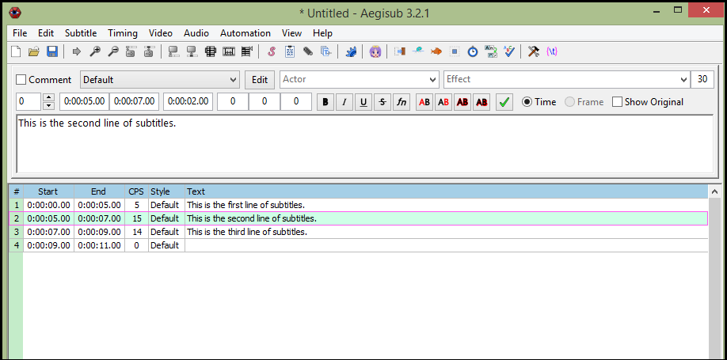

1. When you finish editing subtitles, click **File | Save Subtitles** to save the subtitles file.

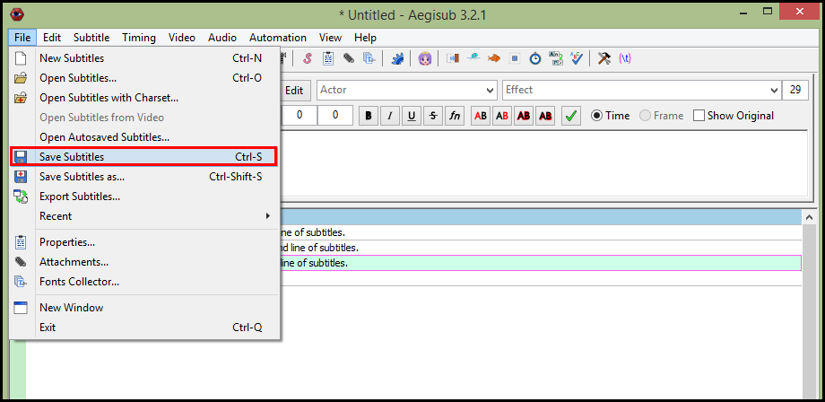

1. Type the file name in the **File name** field, and click the **Save** button to save subtitles file.

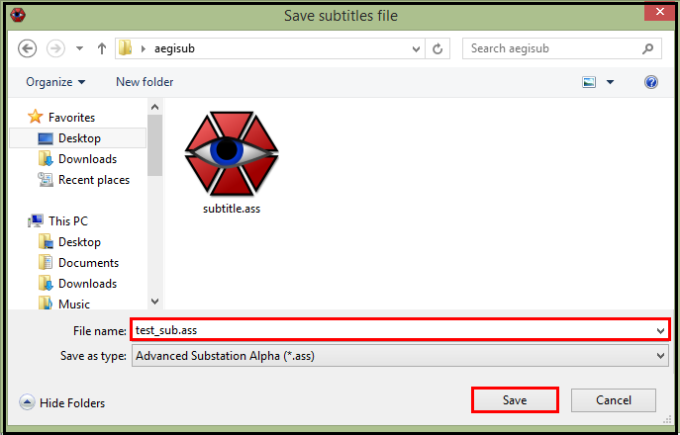

# Working With Styles

When you work with typesetting, you are actually working with styles. A style is a set of parameters regarding how subtitle lines are displayed on a video. It is a style that decides the appearance of your subtitles on a video.

In Aegisub, styles can be stored in the storage by groups. When you edit subtitles, you can use existing styles in the storage, or create new styles.

After you create a new style, you can save it to the storage for later use. If you are just trying a style to see if it is suitable for your subtitles, you can keep it in the current scripts area. If you do not copy a new style from current script area to the storage, you lose the style when you close the Aegisub program. In the subtitles manager, you can move a style from storage to current scripts area, or vice versa.

The styles manager and the style editor are two built-in tools. You use the styles manager to manage styles. You use the style editor to edit an existing style or create a new style.

Step 2 in the Editing Subtitles shows you how to select an existing style for a current subtitle line.

To learn how to use the style manager, see The Styles Manager.

To learn how to use the style editor, see The Style Editor.

You can find step-by-step instructions on how to design a style in the section on the topic Designing a Style.

# The Styles Manager

In Aegisub, you use the styles manager for organizing, saving, editing, and deleting styles. The styles manager organizes all stored styles into groups. Each group is called a storage.

To open the styles manager, you go to main menu to click **Subtitles | Styles Manager....**

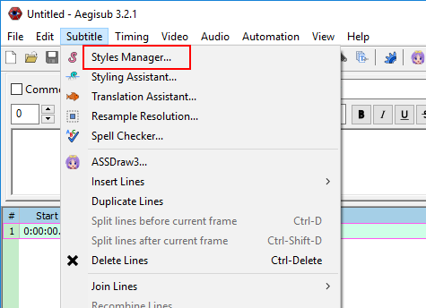

Thestyles manager displays.

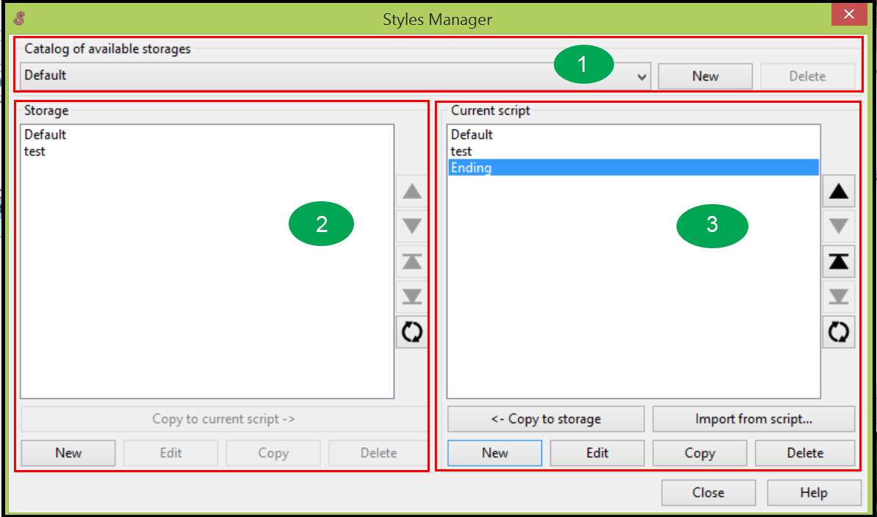

The styles manager has three main areas:

|  |  |
| --- | --- |
| http://ylpeng.com/writings/aegisubHelp/images/1.png | Catalog of available storages: You can select a storage from available storages. You can also create a new storage and delete an existing storage. |
| http://ylpeng.com/writings/aegisubHelp/images/2.png | Storage: All styles in the selected storage display under Storage. You can create a new style for the storage, edit an existing style in the storage, and delete an existing style from the storage. You can copy an existing style from storage to current script area. |
| http://ylpeng.com/writings/aegisubHelp/images/3.png | Current script: This area keeps your current styles. Only styles in the current script area display in the drop-down style list when you edit subtitles. Therefore you have to move a style from storage to the current script area before you can use it for editing subtitles. You can create a new style in the current script area, edit an existing style in current script area, and delete an existing style from current script area. You can copy your newly created style or edited style to the storage by clicking **<- Copy to Storage** button. You can also import a style from an existing scripts file. |

There are five buttons on the left side of storage (and current script). The first four buttons let you move one style up, down, to the top, and to the bottom. The lowest button lets you sort styles by name alphabetically.

If you need help, you can click **Help** button, which leads you to the online help manual.

When you finish your operations in the styles manager, you click **Close** button to close the styles manager.

# The Style Editor

You use style editor to create a new style or edit an existing style. The style editor has a WYSIWYG (what you see is what you get) user interface. When you change the parameters of a style, you can see exactly what your subtitles look like.

Open the styles manager first. See The Styles Manager.

To open the style editor, you click **New** button or **Edit** button in the style manager.

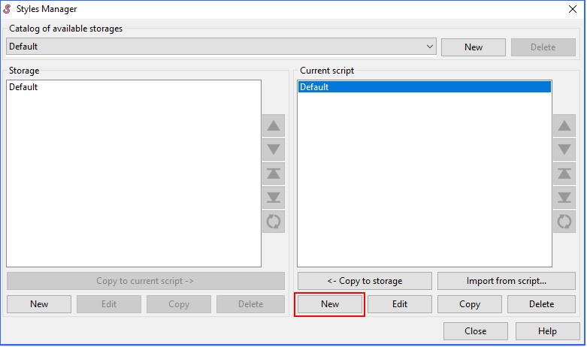

The style editor displays.

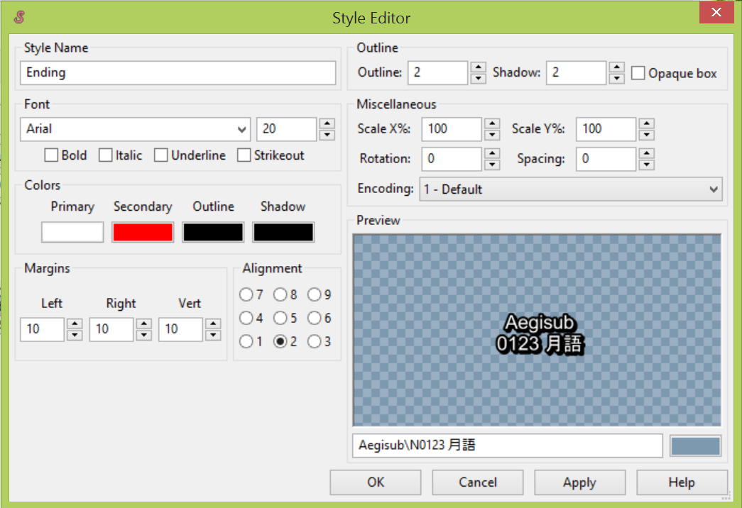

**Style Name:** You type your style name in the **Style Name** field. You might have different styles for the beginning, the ending, or voice-over for your video. You can give meaningful names for different styles.

**Font:** You select the font family and font size of the style.

**Check boxes:** You can make the subtitles bold, italic, underline, or strikeout by checking the box beside **Bold**, **Italic**, **Underline**, or **Strikeout**.

Margin and alignment: You can define the position and margins for subtitles on the video.

**Outline:** You define the width for the outline and shadow. You can also select whether the subtitles are opaque or not.

**Miscellaneous:** You can change the scale in X direction, the scale in Y direction, and the angle of the subtitles. You can also set the space between characters.

**Encoding:** You can select encoding format from the drop-down list.

**Preview area:** You can see the exact result when you change parameters in the style editor.

In the field under the preview area, you can type the sample subtitles.

The color rectangle under the preview area is for you to set the background color for sample subtitles in the preview area.

Click **Help** button to see online help manual.

Click **Apply** button to apply your changes to subtitle lines that use the style.

Click **Cancel** button to close the style editor without saving your changes.

Click **OK** button to save your changes and close the style editor.

# Designing a Style

Style design enhances the readability and aesthetic effects. It is a very important task in the process of adding subtitles to a video. You design a style using the styles manager and the style editor. You can design the font, size, color, outline, and shadow of subtitles. In the preview area of the style editor, you can see the result while you change the parameters of the style. You can also save a style in your storage for later use.

To design a style:

1. From the menu, click **Subtitles | Styles Manager....**



The styles manager displays.

1. Click **New** button under Current script area to create a new style under Current script area.

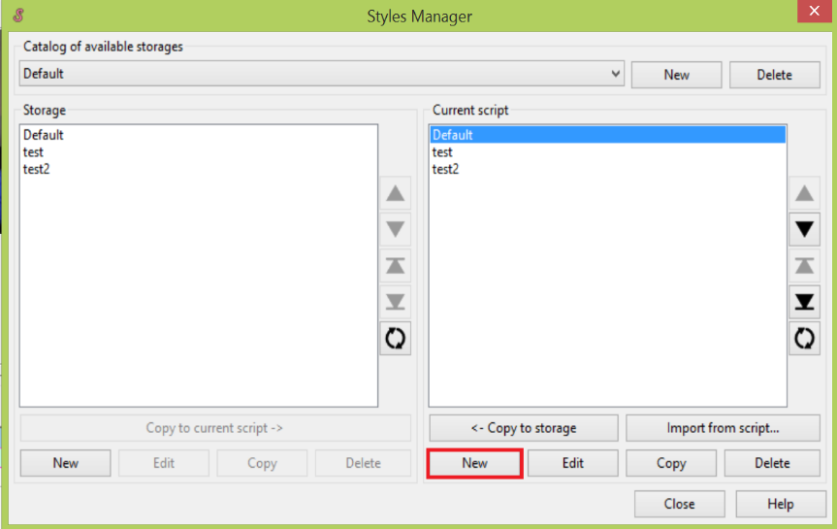

The style editor displays.

1. Type desired name for your style in the **Style Name** field.

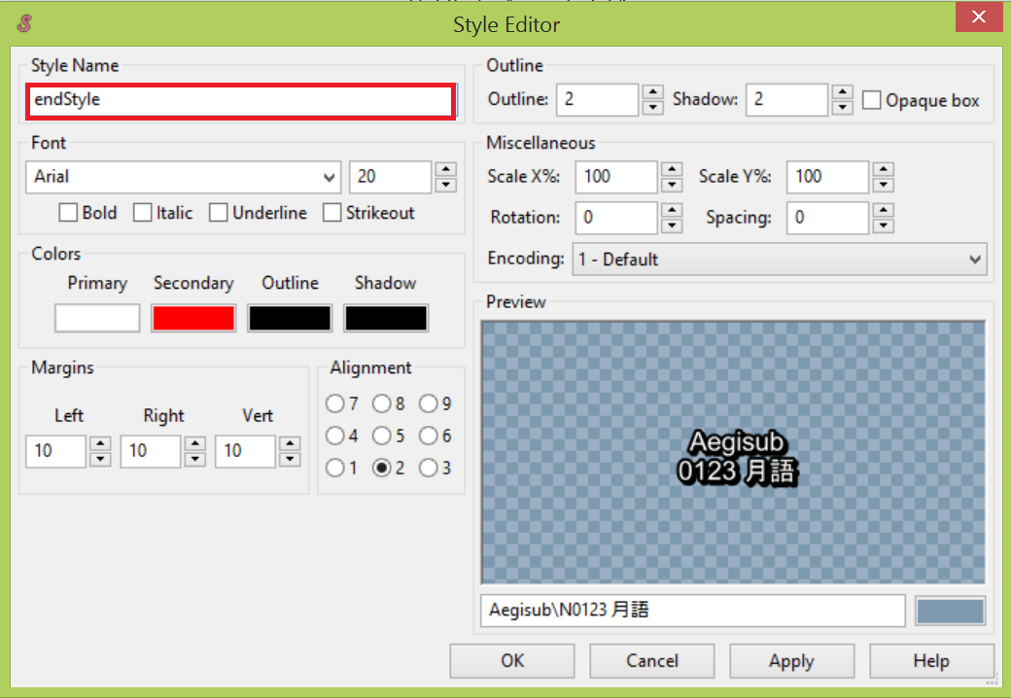

1. To design the style, do one or more of the following actions:

* Select font and size of the style.
* Select color for primary, secondary, outline, and shadow of the style.
* Select margin and alignment for the style.
* Select width for outline and shadow for the style.
* Select whether subtitles are opaque.
* Select X scale, Y scale, rotation angle, and space between characters.
* Select encoding format.

You can see the result in the preview area when you change the settings.

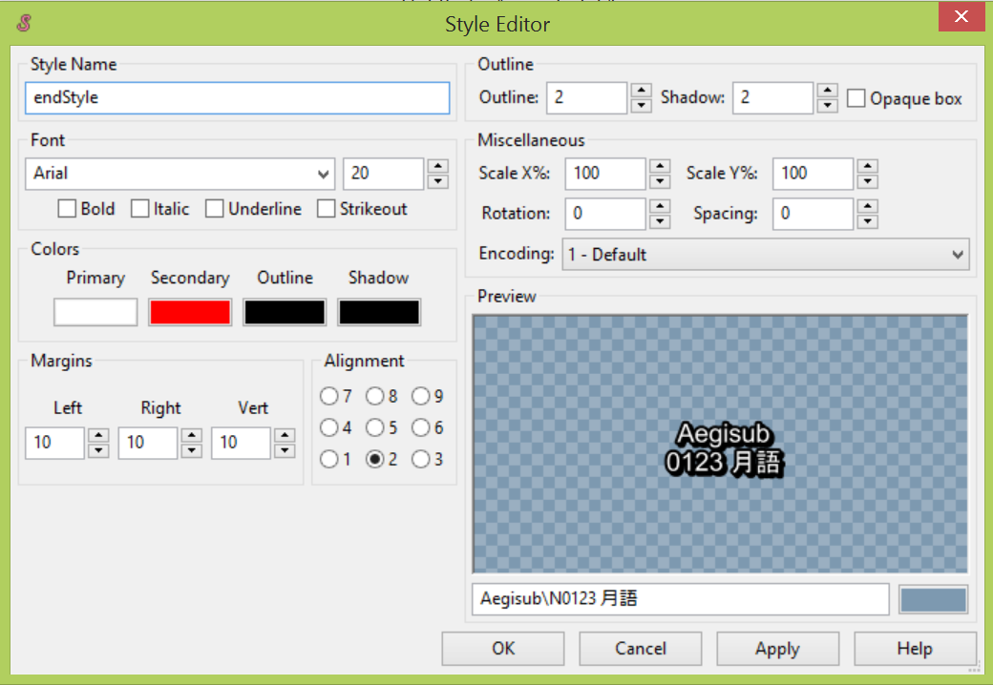

1. Click **Apply** button to apply the changes for subtitles on the video.

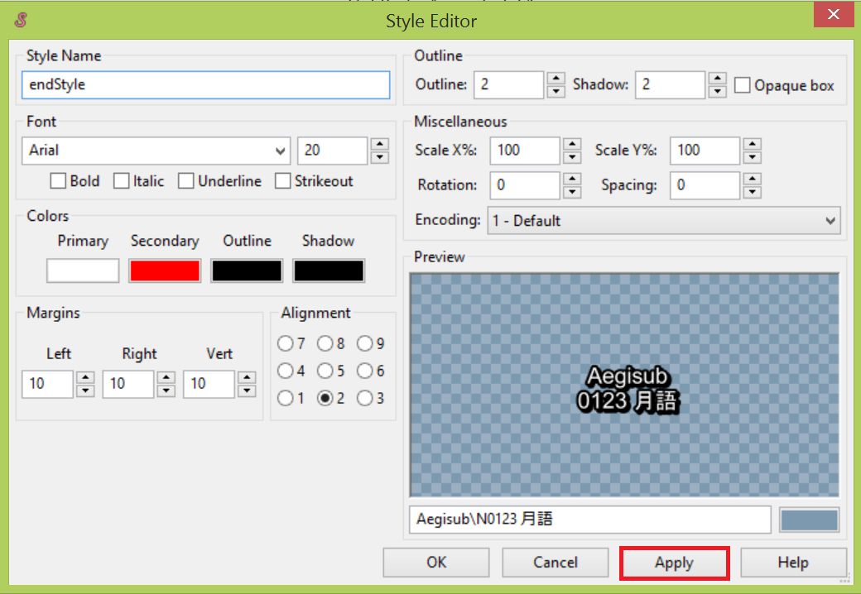

1. Click **OK** button to close the style editor.

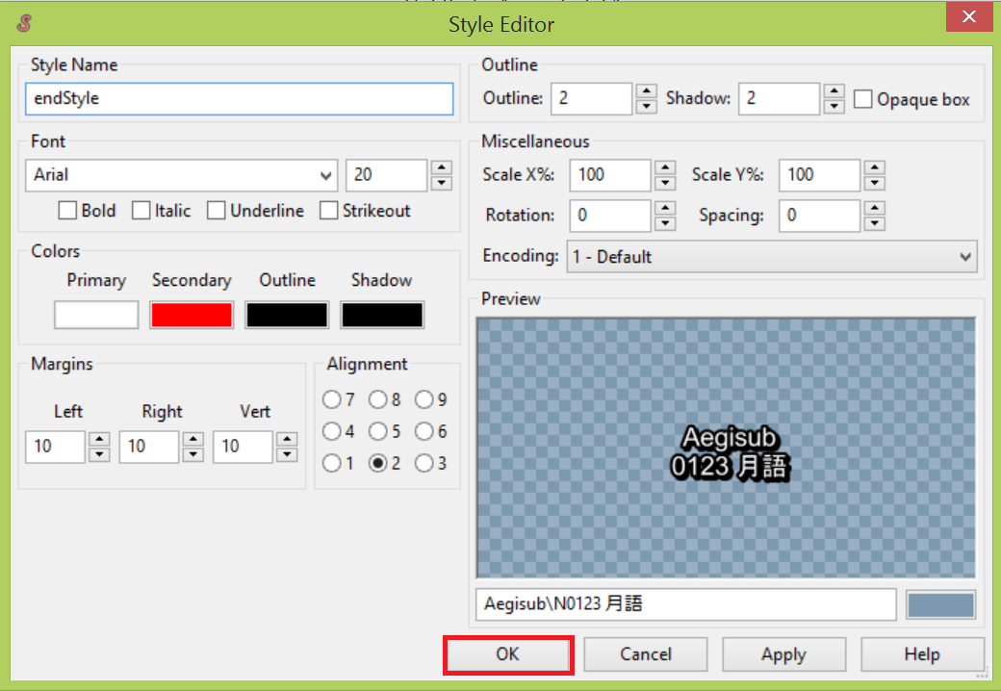

1. Click **<- Copy to storage** button to save the newly designed style to storage.

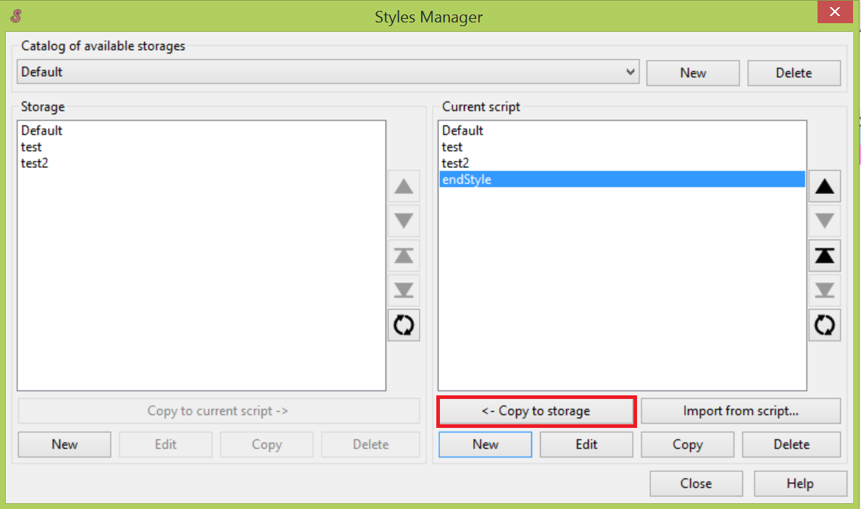

1. Click **Close** button to close the style manager.

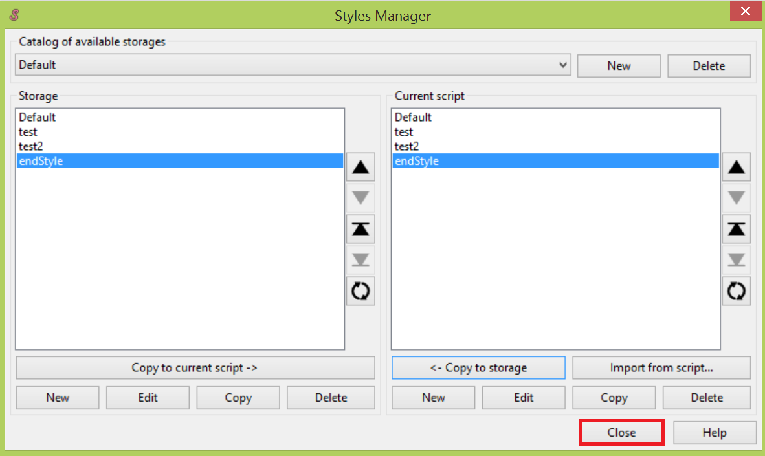

# Timing Subtitles to Audio

Timing subtitles to audio is a critical task in the course of adding subtitles to a video. It is crucial because timing subtitles lets the audience see the subtitles at the same time they are listening to the corresponding scripts. Every line of subtitles needs to be timed to match its audio presentation.

To time subtitles to audio:

1. From main menu, click **File | Open Subtitles** to open a subtitles file.  
   Subtitles display in the subtitles grid.

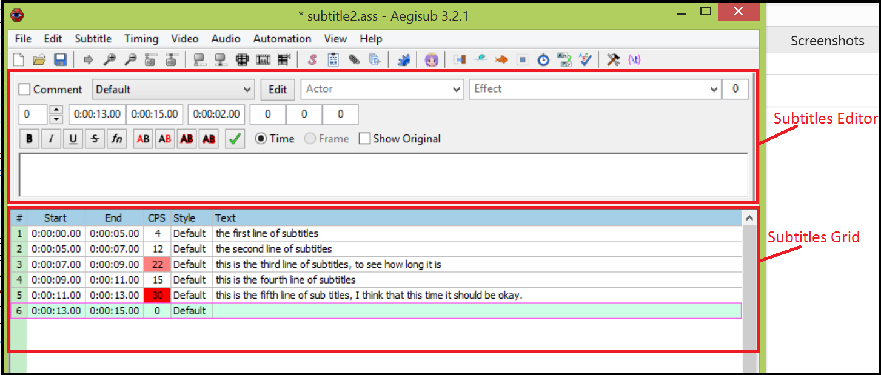

1. From main menu, click **Audio | Open Audio** to open the Audio file you want to add subtitles to. Audio displays in waveform in the audio area.

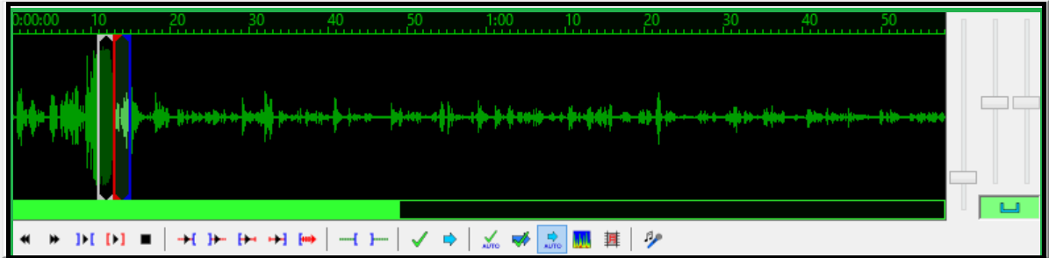

1. In the subtitles grid, click the subtitle line you want to time to audio. The selected subtitle line displays in the subtitles editor.

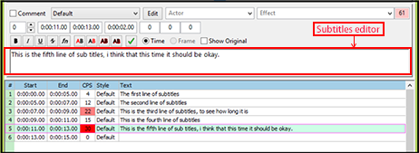

1. In the audio area, click **Play** button to play and listen to the audio. When you locate the start time point of the corresponding speech (e.g., start point of one sentence), click and drag the red line (start line) to the start point.

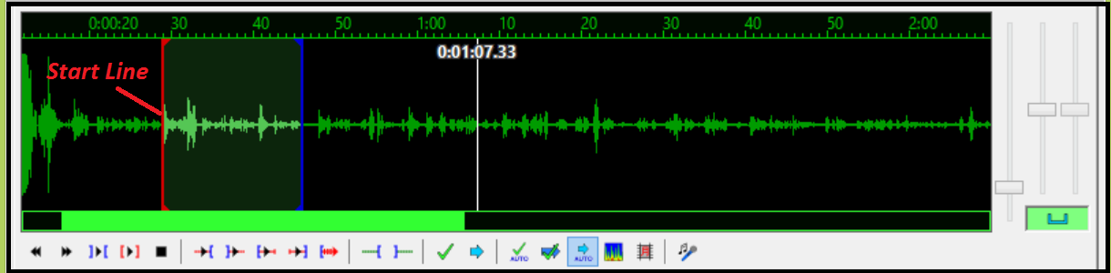

1. In the audio area, click **Play** button to play and listen to the audio. When you reach the end time point of the speech (e.g., end point of one sentence), click and drag the blue line (end line) to the end point.

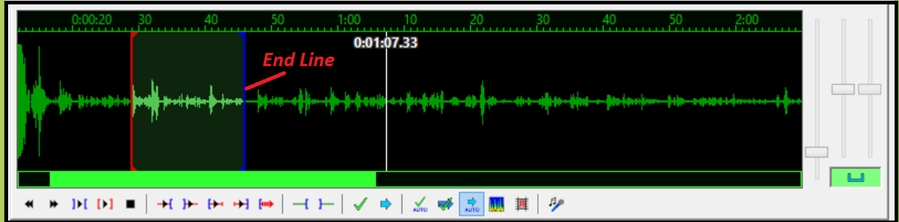

1. Click **Commit** button (the button with green check-mark) under the waveform. The start and end time points are set up for the subtitle line.

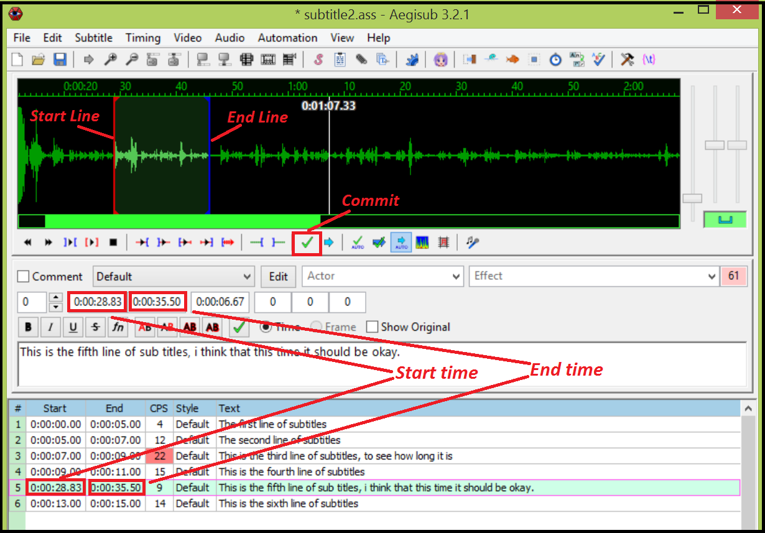

1. Look at the **CPS** field in the subtitles grid (multi-line subtitles area):

* If the **CPS** field is red, adjust the line length of subtitles (See "Editing Subtitles") and then repeat steps 1 to 6.

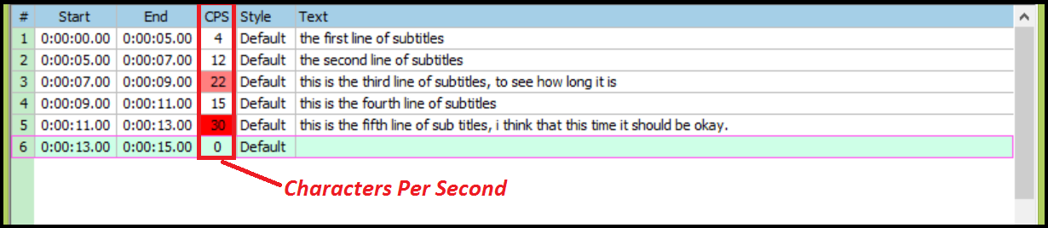

* If the **CPS** field is not red, this subtitle line is successfully timed to audio.